## for 2020 Building Performance Analysis Conference and SimBuild co-organized by ASHRAE and IBPSA-USA

# ABSTRACT

With the increasing interest in grid-interactive efficient buildings, energy storage technologies in buildings are being re-evaluated for their role in the future grid. Ice thermal energy storage (ITS) has a large potential to provide load flexibility to a grid dominated by variable generation assets but requires careful design, analysis, and control to be effective. This evaluation is possible using building energy simulations but is not often done because of the complexity and added time related to add ice storage to building simulation models. The objectives of this study are two-fold: (1) automate the addition of ice energy storage to building models through OpenStudio measure scripting and (2) evaluate the load flexibility potential of example TES design and control strategies. This paper presents a new OpenStudio measure that provides the ability to easily and accurately model a variety of potential design options and common control schemes. After applying this measure, we then bound the ability of the building to increase or decrease its predicted future electric load over 30-minute to 6-hour windows using chiller and ice storage performance constraints at each simulation timestep. Finally, we evaluate the ITS performance with an in-simulation demand response tester.

# introduction

The increased variability of the grid due to the growth of renewable generation assets and distributed energy resources (DERs) requires dynamic demand response for buildings. One of the largest electrical end-uses within buildings is space conditioning, accounting for 9% of the total U.S. electricity production, and up to 50% of a building’s total electricity demand (EIA 2012). This vast amount of energy use is theoretically controllable through the use of thermal energy storage. Ice has traditionally been used to shift on-peak daytime cooling loads to off-peak nighttime hours, capable of providing significant energy cost savings (Henze, Krarti et al. 2003); and if properly sized and controlled, a reduction in total energy use (MacCracken 2003). In a grid dominated by renewables however, this strategy may be insufficient – the flexibility of a given system’s design and control sequence should also be assessed. Some recent work on the value ITS for flexiblity and promoting penetration of renewables has begun exploring this topic (Van Asselt, Reindl et al. 2017, Tang, Wang et al. 2019).

The U.S. Department of Energy Buildings Technology Office (BTO) characterizes building demand flexibility as (1) energy efficiency, (2) load shifting, (3) load shedding, and (4) load modulation (Neukomm, Nubbe et al. 2019). ITS can help address the first three of these aspects. The traditional design approach to ice systems is based on load shifting evaluated over a design-day. Chillers may then be downsized, thereby decreasing capital cost and improving device efficiency during part-load operation (Glazer 2019). These factors then impact the building’s overall efficiency, with potential to reduce energy use intensity (EUI).

Ice storage also provides a load shedding ability within a building. The ice available within the storage tank at each point in time can be converted into a temporary reduction in building electrical demand (load shed). Conversely, a partially discharged ice tank and/or a chiller operating with a demand limiter provides an opportunity for a temporarily increase in building demand while saving the stored ice for later (load add). This may be a useful service in the event of excess renewables that might otherwise be curtailed. Thus, ice storage system designs and controls should be evaluated for their ability to provide both load shed and load add in a grid-interactive manner.

Ice storage does not lend itself to load modulation as the timesteps (seconds and sub-seconds) are too small.

In order to perform load flexiblity assessments, detailed whole-building energy modeling (BEM) that incorporates the ice energy storage model with accurate controls is required. While most BEM software include an ice storage model, implementation is a time-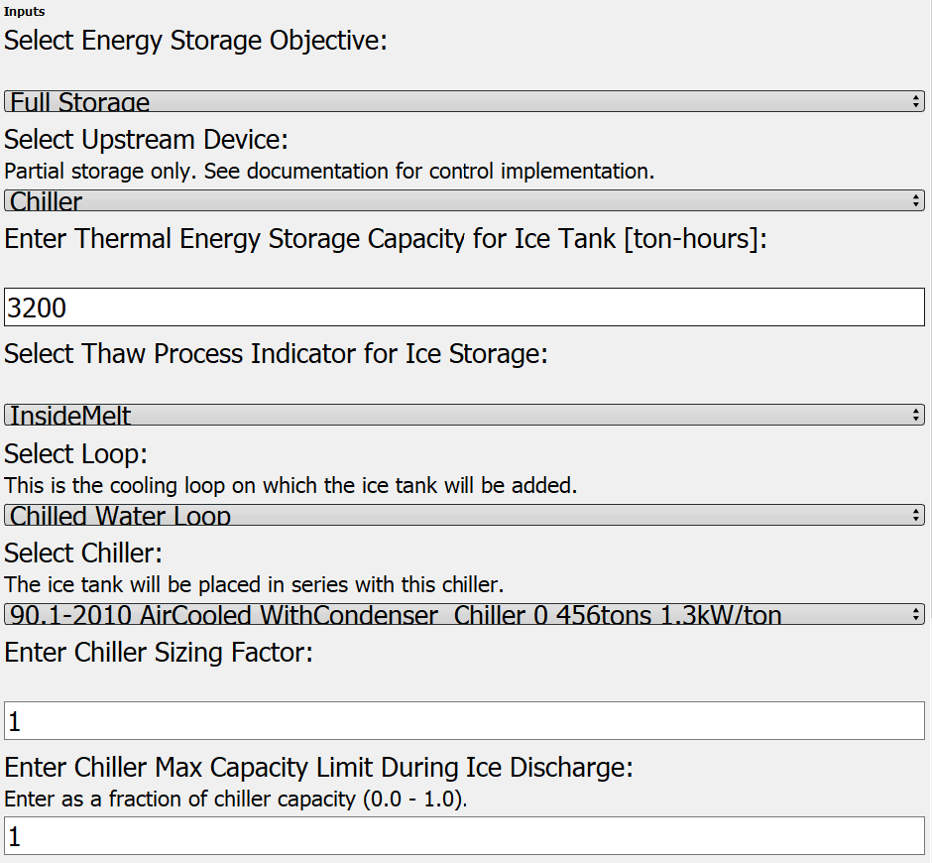consuming, custom endeavor, which limits parametric analysis potential (Glazer 2019). Furthermore, controlling the ice storage models may require scripting within the HVAC iteration loops in order to achieve performance similar to real-world applications. These challenges have limited the analysis of ITS within BEM to date.

It is the objective of this paper to present a method to automate the implementation of ITS within BEM and allow users to quickly define and evaluate a wide variety of possible control schemes, even permitting the testing of a system during a simulated demand response event. This allows rapid parametric analysis of possible ice storage system designs and control strategies. We demonstrate the measure on a single building model, but explore several configuration and control options, examining the impacts on building energy efficiency, load shifting, and load shed/add potentials.

METHODOLOGY

Measure Description

The BEM engine used for this project is DOE’s EnergyPlus, using the ThermalStorage:Ice:Detailed object, accessed through the OpenStudio SDK. The OpenStudio user interface is used for model articulation with integration of ITS configurations and controls is achieved through an OpenStudio measure (script). The measure can be implemented directly within the graphical user interface, from the command line, or as part of a workflow. The measure may be applied to any OpenStudio model that includes a chilled water loop.

The configuration options available in the measure include the ice tank position relative to chiller, the ice tank capacity in ton-hours, and a chiller capacity multiplier.

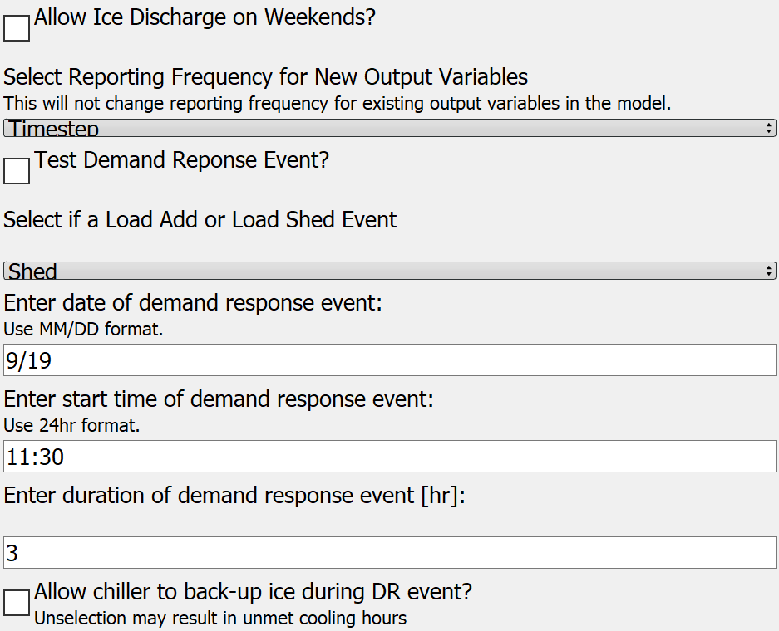The high-level control strategies available within the measure are those defined by the ASHRAE Design Guide for Cool Thermal Energy Storage:

* Full Storage, where the ITS meets the entire cooling load during discharge; and,
* Partial Storage, where cooling loads are met by simultaneous operation of both the chiller and ITS.

Within partial storage, there are many additional control considerations, such as load-leveling, demand-limiting, and chiller or storage-priorities. All of these may be implemented through user-inputs within the measure, thus allowing comparative analysis. Due to the the nature of BEM, demand limits [kWe] on the chiller are implemented as capacity limits [kWth] within simulation. Figure 1 shows a selection of the measure’s user inputs related to ITS configuration and controls; control shedule options are not shown.

Figure : Select user inputs for ITS measure

All controls, with the exception of the chiller capacity limter, are provided through component operating schedules, which are created by the measure for the user. Custom schedules generated by the user may also be applied. The chiller capacity limiter is controlled by a simple Energy Management System (EMS) script inside the HVAC iteration loop.

One additional feature of the measure is an optional supervisory control EMS script that can be used to test individual demand response (DR) events. The DR tester will override the ITS controls for a user-specified event time and duration to either maximize (load add) or minimize (load shed) energy use associated with space cooling. The in-simulation tester is valuable for exploring the rebound effects associated with using ITS for dynamic load flexiblity. Figure 2 shows the user inputs for the DR tester.

Figure : User inputs to test a DR event

## Flexibility Metrics and Methods

We evaluate our ITS models against a variety of energy metrics associated with the BTO’s characterizations mentioned above. Cost metrics are specifically avoided here as they will be functions of not only design and control, but also local utility rates and programs. This measure provides a tool to help evaluate ITS within any price structure.

Load shifting is evaluated relative to a baseline system without ITS. It involves both a shed period, when the ITS is discharged; and a load add period, when the ice is charged. The peak power reduction [kWe] during discharge and the total electric energy shifted [kWh], evaluated over at least one complete charge/discharge cycle are useful. We employ the four metrics below to characterize the load shifting potential of our example ITS models:

Average Daily Shifted Load [kWh], defined as the average reduction in facility electricity use during ice discharge, relative to the baseline;

Average Fraction of Daily Load Shifted [-], defined as the average of the daily shifted loads divided by the average daily total electric load in the baseline;

Annual Total Shifted Load [MWh], which is the sum of the reductions in daily facility electric load during ice discharge, relative to the baseline; and,

Maximum Annual Peak Demand, which is the single point of maximum facility electric demand (15-minute average) over the course of the year.

Monthly values for peak demand are of interest for utility rate calcuations; but for brevity, we here present only the annual peaks.

Energy efficiency is evaluated at the building level with EUI, and at the chiller level through three metrics evaluated over the ITS operating season to capture charge and discharge performance:

* Chiller Average COP;
* Chiller Total Electricity Use; and,
* Chiller Total Runtime Hours.

Load shed and load add potentials are assessed through both post-processing of simulation results and through the in-simulation DR tester. They are quantified in terms of peak power [kWe], energy [kWh], and potential duration of flexibilty [hours] at each simulation timestep. We perform the calcuations for DR events ranging from 30-minutse to 6 hours.

For the load shed events, we assume that ITS controls switch to full storage for the duration of the event, thus allowing the chiller to turn off. If the ITS state-of-charge is insufficent to meet the full load (either energy or cooling rate) over the required duration, we indicate a 0 flexiblity potential. We do this to identify the limits of a particular ITS control strategy for early-design consideration.

For load add events, we assume that the chiller will meet the full cooling load. Any ice that would have been discharged during the DR event is saved for later use.

We aggregate these calculations, performed at each timestep for each DR window (30-min to 6-hours), into average potenial power change [kWe], average potential energy change [kWh], and percent of timesteps over which the shed or add responses could be successfully executed.

These add and shed potentials derived from post-processing provide information on the flexibility that the building may provide to the grid only during the DR window; they do not captutre any rebound effects. In the case of the load shed events, negative rebound impacts may occur immediately following the DR event or several hours later during ice tank recharge. The in-simulation DR tester allows us to use BEM to capture those rebound effects. These are best explored through visual examination of the timestep energy output data.

## Simulated Building Test Cases

To demonstrate the capabilities of this measure and our load flexiblity analysis, we use the DOE Prototype Secondary School, vintage 90.1-2010 for climate zone 2A. We use the Houston, TX TMY3 weather file and simulate using 15-minute timesteps. We select this building model and location because (1) the baseline model includes a chilled water loop with an air-cooled chiller model, (2) the facility requires space cooling for the entire year, and (3) space cooling constitutes a large percentage of the total facility electric load. In order to facilitate study repeatability, no changes are applied to the model beyond our ITS measure.

To showcase the potential of the measure five different ITS configuration and control cases are modeled and presented here. Models with a “P” title are partial storage configurations.

Table : Model configurations

|  |  |  |  |
| --- | --- | --- | --- |
| Model Name | Chiller Capacity | ICE  capacity | UpStream Device |
| *Units* | *Tons (kWth)* | *Ton-hr (GJ)* | *-* |
| Base | 578 (2,033) | N/A | N/A |
| Full | 578 (2,033) | 3,200 (40.5) | Ice |
| P1 | 405 (1,424) | 2,000 (25.3) | Ice |
| P2 | 405 (1,424) | 2,000 (25.3) | Chiller |
| P3 | 347 (1,220) | 2,000 (25.3) | Chiller |

Table 1 lists the five models and their basic configuruation options. Using percentage multipliers, the chillers in P1-P3 are downsized from the original baseline. Chiller capacities shown are the result of a 70% multiplier in models P1 and P2, and a 60% multiplier in P3. These multipliers are selected based on the ASHRAE Design Guide for Cool Thermal Storage sizing equations and recommendations in order to demonstrate the performance of systems with downsized chillers.

Table 2 defines the high-level control strategies applied in each model. For model P1, the limiter imposed on the chiller during ice discharge is a function of a fixed temperature difference across the downstream chiller evaporator. This is applied using temperture setpoints schedules, rather than the EMS limiter script used in P2 and P3.

Table : Model control strategies

(* Limit imposed with schedules rather than EMS script.)

|  |  |  |  |
| --- | --- | --- | --- |
| mODEL | sTRATEGY | pRIORITY | lIMITER |
| Base | N/A | N/A | N/A |
| Full | Full Storage | N/A | N/A |
| P1 | Partial Storage | Chiller | 57%* |
| P2 | Partial Storage | Ice | 65% |
| P3 | Partial Storage | Ice | 68% |

The cooling season for these models is the entire year. The full storage model is charged from 2100-0800 daily, and discharged from 0900-1800 on weekdays. The partial storage models are charged from 2300-0800 every day, and discharged from 0800-2100 on weekdays. The chilled water loop temperature is 44°F (6.7°C) with a design loop temperature difference of 10°F (5.6°C). The charging setpoint temperature is 25°F (-3.9°C) and the working fluid is 25% etheylene glycol.

These models are selected to concisely demonstrate the variety of configuration and control options made available through the OpenStudio measure.

To demonstrate the flexibility analysis described above, we select one model for further examination. Model P2 (partial storage, chiller-upstream, storage-priority, with a 65% chiller capacity limiter imposed during ice discharge) is selected because it produces an approximately equivalent EUI to the baseline model, and has nearly identical chiller electric energy use over the course of the year.

# Results

Comparing Example Models to Baseline

All five models are evaluated in terms of energy efficiency and load shifting over the entire cooling season, and all five meet zone temperature requirements for full the year. These are shown for measure demonstration purposes; conclusions on the superiority of a configuration or control strategy should not be drawn from the data below. Such conclusions will depend on the building type, climate, and energy objectives.

Table 3 summarizes the energy results for the models.In terms of energy efficiency, all example ITS models are within +1.2% to -2.0% of the baseline EUI. However, all ITS models reduce the facility peak electricity demand during the ice discharge season. The peak values shown in the table are the maximum facility demand over the year; average monthly reductions range from 14-27%. The ITS examples produce no increase in unmet hours; and the ice is never fully depleted.

Table : Model energy comparison of annual metrics

|  |  |  |  |
| --- | --- | --- | --- |
| Model | EUI | Peak Demand | Min SOC |
| *Units* | *kBtu/ft2* | *kWe* | *-* |
| Base | 49.49 | 989 | N/A |
| Full | 50.10 | 797 | 12.3% |
| P1 | 49.26 | 795 | 14.3% |
| P2 | 49.60 | 801 | 11.4% |
| P3 | 48.81 | 764 | 1.5% |

Table 4 lists key chiller performance data. Examining the chiller performance between models highlights the tradeoffs in energy use, runtime, and efficiency associated with ITS designs. All ITS models improved the average chiller efficiency, shown below as an annual average, but most incur either increased usage (P1 and P3) or increased energy consumption (Full). P2 produced nearly identical total chiller energy use, but had 150 fewer runtime hours over the year – when the ice-priority discharge was sufficient to provide full storage. This occurred occasionally in the winter and shoulder seasons.

Table : Model chiller comparison

|  |  |  |  |
| --- | --- | --- | --- |
| Model Name | Chiller Electricity | Average COP | Chiller  Runtime |
| *Units* | *kWe* | *-* | *hours* |
| Base | 963 | 2.55 | 5,945 |
| Full | 980 | 2.71 | 4,346 |
| P1 | 942 | 2.76 | 6,286 |
| P2 | 963 | 2.68 | 5,794 |
| P3 | 918 | 2.79 | 6,029 |

It is noteworthy that P2 uses the same energy for the chiller, but produces a higher EUI compared to the baseline. This is due to increased energy use associated with pumping the working fluid at lower temperatures.

To better illustrate the variation in model performance, average weekday facility demand profiles for the month of September are shown below in Figure 3. The full storage model provides the greatest impact in facility demand relative to the partial storage models, but does so for a shorter duration (9 vs. 13 hours), with a higher storage capacity requirment (3,200 vs. 2,000 ton-hours), and without the economic benefits of downsizing the chiller. P1 and P2 both have the same size chiller, but the impact of the discharge priority and chiller limiter is observed throughout the day. Models P2 and P3 have the same configuration and very similar controls strategies during discharge. However, the larger chiller in P2 recharges the ice tank more quickly each night and at a higher power requirement.

Figure : September average daily demand profiles

Table 5 summarizes the load shifting achieved by each ITS model. Load shifting occurs over 260 days out of the year (no weekends) and constitutes between 7.4% and 13.3% of the total facility electric load each day. Model P1 is signifcantly lower than the other ITS models due to the static chiller-priority control applied. This results in less average daily ice utilization compared to the ice-priority control, despite the lower fractional limiter placed on the chiller.

Table : Electric load shifting relative to baseline

|  |  |  |  |
| --- | --- | --- | --- |
| Model Name | AvG Daily Shift | % Daily shift | Annual Total |
| *Units* | *kWh* | *-* | *MWh* |
| Full | 1,240 | 12.5% | 323 |
| P1 | 727 | 7.4% | 189 |
| P2 | 1,185 | 12.0% | 308 |
| P3 | 1,315 | 13.3% | 342 |

The annual total shifted load cannot be directly converted into energy bill savings, but does illustrate the magnitude of the flexibility in energy consumption provided by a given ITS design. Its value is most easily visualized using a load-duration curve, where a flatter profile means a more uniform energy demand by the facility over the year. Figure 4 shows the load duration curves for all five models. All ITS models are flatter than the baseline to varying degrees, illustrating the impact of control selections within the energy simulation.

Figure : Load duration curves

Load Add/Shed Flexibility Through Post-Processing

Model P2 is used for further flexibility analysis through both post-processing and the in-simulation DR tester. The post-processing method bounds the energy use of the facility at each timestep by modifying the ITS controls for a maximum shed or add reponse, but it does not account for any rebound effects after termination of the DR event.

Table : Summary of annual load shed potentials

|  |  |  |  |
| --- | --- | --- | --- |
| DR eVent Duration | AvG Peak demand Shed | average energy shed | Avail |
| *Hours* | *kWe* | *kWh* | *-* |
| 0.5 | 128 | 63 | 57% |
| 1 | 123 | 120 | 48% |
| 2 | 115 | 208 | 33% |
| 3 | 108 | 267 | 26% |
| 4 | 100 | 321 | 22% |
| 5 | 98 | 386 | 20% |
| 6 | 103 | 466 | 18% |

Table 6 summarizes the load shed potentials of model P2, aggregated over the entire year. The average shed values represent the average reduction in facility peak demand that can be achieved over the duration of the DR event, relative to normal operation. The average energy shed represents the average reduction in facility energy use relative to normal ITS operation. This shed potential is available for a certain percentage of the year, when cooling loads are present and the ITS state-of-charge is sufficent to meet them. The “AVAIL” column tabluates the percentage of timesteps in the year at which a full-storage demand response control is feasible for the entire event duration specified. These results assume no-notice demand response signals, where no preparatory changes in ITS operation are made prior to the event.

Table : Summary of load shed during occupied hours

|  |  |  |  |
| --- | --- | --- | --- |
| DR eVent Duration | AvG Peak demand Shed | avG energy shed | Avail |
| *Hours* | *kWe* | *kWh* | *-* |
| 0.5 | 127 | 63 | 68% |
| 1 | 126 | 122 | 61% |
| 2 | 115 | 209 | 43% |
| 3 | 106 | 270 | 31% |
| 4 | 100 | 310 | 22% |
| 5 | 93 | 314 | 17% |
| 6 | 90 | 322 | 15% |

Table 7 presents the same analysis, but limited only to facility occupied hours, here defined as 0800-2000 on weekdays. In this example, the P2 configuration and control provides a shed flexibility potential of 127 kWe for 30-minute events over 63% of all occupied hours. However, for 6-hour DR events, only 90 kWe reduction in peak demand can be provided over 15% of occupied hours.

Table : Summary of load add potentials

|  |  |  |  |  |
| --- | --- | --- | --- | --- |
| DR Event Duration | Annual | | Occupied | |
| AVG ADD | Avail | AVG ADD | Avail |
| *Hours* | *kWh* | *-* | *kWh* | *-* |
| 0.5 | 65 | 39% | 66 | 94% |
| 1 | 126 | 41% | 130 | 98% |
| 2 | 234 | 44% | 257 | 100% |
| 3 | 329 | 47% | 376 | 100% |
| 4 | 413 | 50% | 486 | 100% |
| 5 | 487 | 53% | 586 | 100% |
| 6 | 553 | 56% | 675 | 100% |

Table 8 displays the results of an analysis for load add events. The availability is restricted to hours with cooling load and the chiller operating at a restricted capacity. By eliminating the chiller restriction and stopping ice discharge, facility power demand is increased; the ice tank state of charge is preserved for later use. Changes in peak demand are not displayed, as they are less pertinent during a load add event. Only average energy use increases are presented with their associated annual and occupied-hour availabilities. During occupied hours, it is nearly always possible to absorb additional energy as the chiller is operating under partial storage. During the late evening and early morning hours, cooling loads are small and are already being met by the chiller. This explains why the availabilities of the load add potentials during occupied hours are much higher than the full-year potentials.

This post-processing assessment presents a method to characterize the load add/shed flexiblity of a given ITS configuration and control strategy, for consideration in the early design stage. If regional utility programs heavily incentivize periodic load shed events, similar analysis can help system designers size ITS to ensure sufficient capacity will likely be available. If excess renewables frequently result in curtailed PV-generation, the analysis can quantify the potential service that a given ITS design might provide to help maximize renewable utilization.

Through the development of this measure, such analysis may now be readily repeated on a wide variety of potential ITS designs within the OpenStudio platform.

Load Flexibility Testing in-Simulation

As previously noted, post-processing does not capture the rebound effects of changing ITS control strategies in reponse to a DR event. We select a two days during a peak-cooling week within the P2 model to test and illustrate the broader effects of using the ice for load add/shed flexiblity. A three-hour load shed event is simulated on September 19th, beginning at 11:30 a.m. A five-hour event is simulated for both load add and load shed on September 21st, beginning at noon.

Discharge

Charge

Figure : 3-hr load shed event on Sept. 19, indicated by dashed lines. Rebound effects observed at end-of-day and during recharge.

Figure 5 shows the impacts of the three-hour shed event on September 19th from 11:30 to 14:30. Facility peak demand during the event is reduced by 239 kWe, from 787 kWe to 548 kWe. The total additional energy shifted out of the window is 688 kWh. There is no change to peak demand outside the DR event window. The ice is sufficient to supply full storage during the DR event. However, due to the additional depletion mid-day, the ice runs out before the end of the day, thus requiring additional chiller cooling over the last few hours of occupation. The required ITS recharge time is extended relative to the routine operation profile.

Figure : 5-hr load shed event on Sept. 21, indicated by dashed lines. Chiller operation is prohibited during DR event and ice is insufficient to meet full load. Rebound effects are immediate and severe. Recharge time is also extended.

Figures 6 through 8 show the potential impacts of a longer DR event. This day is selected because it is one of the highest cooling loads throughout the year, thus the chiller and ITS are already operating near their design limits under routine operation. The five-hour load shed is selected to explore the impacts when the ice runs out prior to the end of the DR event.

In Figure 6, the chiller is forced off for the entire event, regardless of the ITS performance. As the ice runs out, at approximately 16:00, there is an obvious increase in facility demand. This is due to the simulation ramping up variable speed pumps and fans in order to try to meet zone temperature setpoints. During the event, peak demand is reduced from 771 kWe to 593 kWe. The additional energy shift totals 1,068 kWh. Immediately following the DR event, at 17:00, the chiller power spikes to provide maximum cooling as it attempts to recover. The spike exceeds the peak demand of the facility during routine operation, increasing from 771 kWe to 807 kWe. As the ice is depleted, the building cannot return to partial storage control following the event; all loads for the remainder of the day must be met by the chiller. Recharge time is increased commensurate with the increased ice discharge.

Figure 7 repeats the DR test previously described, but allows for staged chiller operation during the DR event. As the ice approaches a low state of charge, the chiller is permitted to operate up to 50% capacity. Once the ice fully runs out this chiller limit is relaxed to the routine operation chiller limiter, which is 65% in model P2. This is not meant to simulate a smart controller, but rather to allow chiller operation to begin meeting cooling loads without a large, immediate power spike in the simulation. As the ice runs out early, a large increase in facility demand is obserserved as the chiller turns on at its limited capacity. Peak facility demand during the DR event is now only reduced by 50 kWe, from 771 kWe to 721 kWe. The total electricity use avoided during the event was 901 kWh. Rebound is immediate, but does not cause an increase in facility peak demand for the day. Recharge time is extended as expected.

Figure : 5-hr load shed event on Sept. 21 with chiller operation permitted during the DR event, indicated by dashed lines. Immediate rebound is less severe, but peak kWe reduction during the event is greatly impacted.

Figure 8 shows the performance of ITS under a load add event scheduled for September 21st, beginning at noon. By maximizing chiller usage, and minimizing ice discharge, the facility can temporarily increase its power demand by an average of 106 kWe for those five hours. This value is a function of the building cooling load and chiller capacity, as a downsized chiller may not be able to meet the full load. This would require ice discharge during the add event, but at a reduced rate. Conversely, if the chiller is sufficiently large or the load relatively small, the chiller may be able to go into an ice-make operation during the add event, providing an even greater energy storage service to the grid.

Figure : 5-hr load add event on Sept. 21. Chiller meets full cooling load during event and ice charge hours are subsequently reduced.

The results in Figures 6 to 8 provide the information to bound on the building’s flexiblity over a given DR event window. The potential increases or decreases in power or energy usage both during and after the DR event provide the necessary information to building operators (or smart controllers) to evaluate possible responses to potential grid signals.

Such analysis, previously a tedious, custom endeavor, is now easily performed on any building with a chilled water loop through the use of the OpenStudio measure developed in this project.

# Conclusion

This paper presents an OpenStudio measure to easily model ITS systems for buildings with central chilled water loops. Various hardware configurations and high-level control strategies may be rapidly generated and compared. Furthermore, a built-in DR testing feature allows users to examine the potential impacts, including rebound, of using ITS for flexible demand response.

Four ITS models are generated using the measure and compared to the baseline. With no increase in unmet hours, facility EUI’s fall between +1.2% and -2.0% of baseline. Average daily shifted loads range from 7.4% to 13.3% of total facility electricity use. Total electric energy shifted by these example ITS ranged from 189 to 342 MWh over the course of the year.

One partial-storage model is selected for further flexiblity evaluation. In addition to the load shifting previously quantified, this ITS provides average demand shed potentials ranging from 127 kWe for 30-minute events to 90 kWe for 6-hour events during occupied hours. With routine ITS operation, these potentials are available between 68% and 15%, respectively, of those occupied hours.

Future work will increase the fidelity of chiller limiting controls within the measure and to extend the flexibility analysis to a wide range of ITS designs.

# Acknowledgment

This work is part of a larger effort to develop load flexibility scripting measures and was supported by the U.S. Department of Energy Zero Energy Ready Buildings Initiative.

# Nomenclature

ITS – Ice Thermal Energy Storage

# References

(2019). EnergyPlus V.9.1.0, U.S. Department of Energy.

(2019). OpenStudio 2.8.0, U.S. Department of Energy.

EIA. (2012). "Commercial Building Energy Consumption Survey (CBECS)." Retrieved 5/29/2018, from <https://www.eia.gov/consumption/commercial/>.

Glazer, J. (2019). ASHRAE Design Guide for Cool Thermal Storage**:** 312.

Henze, G. P., M. Krarti and M. J. Brandemuehl (2003). "Guidelines for Improved Performance of Ice Storage Systems." Energy and Buildings **35**(2): 111-127.

MacCracken, M. M. (2003). "Thermal Energy Storage Myths." ASHRAE Journal **45**(9).

Neukomm, M., V. Nubbe and R. Fares (2019). Grid-Interactive Efficient Buildings: Overview, U.S. Department of Energy Office of Energy Efficiency and Renewable Energy**:** 36.

Tang, R., S. Wang and L. Xu (2019). "An MPC-Based Optimal Control Strategy of Active Thermal Storage in Commercial Buildings during Fast Demand Response Events in Smart Grids." Energy Procedia **158**: 2506-2511.

Van Asselt, A., D. Reindl, G. Nellis and S. Klein (2017). Design and Utilization of Thermal Energy Storage to Increase the Ability of Power Systems to Support Renewable Energy Resources**:** 174.